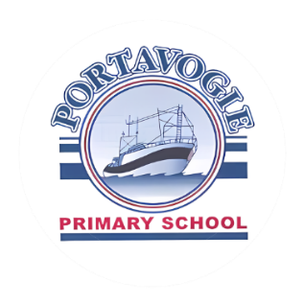
Thank you for your interest in enrolling your child at
Portavogie Primary School and Nursery Unit. We are always
happy to speak to prospective parents.

Admissions September 2026
Parents apply for P1 via the Education Authority application system.
You should check the Education Authority website on how to apply for a place, key dates in the admissions procedure and preschool providers’ admissions criteria for September 2026 admissions https://www.eani.org.uk/parents/pupil-applications-and-grants/admissions

EA Admissions Helpdesk can be contacted by phoning,
028 95985595 Monday to Friday (9am – 5pm)
You can also contact the EA Admissions Helpdesk at the following email address below:

Primary primaryadmissions@eani.org.uk

Below are the important dates in the application process.

Wednesday 10th December 2025 | Admissions criteria for Primary schools published on the EA website.
Wednesday 7th January 2026 at 12 noon | EA Connect opens for online applications for Primary 1.
Wednesday 21st January 2026 at 12 noon | EA connect closes for online applications for Primary 1.
Monday 26th January 2026 by 4pm | Final date/time for late applications.  Final date/time for Change of Preference in Exceptional Circumstances.  Final date/time for documents in support of applications.
Monday 23rd March 2026 | Parents / carers will receive application outcomes via email (where one is held) or by letter.
Why consider a P1 place at Portavogie Primary School?
Selecting the right school for your child is an important decision, and at Portavogie Primary School, we’re here to support you every step of the way. We would love to welcome your child into our P1 class starting in September 2025.
At Portavogie Primary School, we pride ourselves on providing a caring and welcoming environment where every child can thrive. Our dedicated teachers are passionate about helping children reach their full potential, fostering a love for learning from the very start.
This is what we offer:
- A Strong Start: Our P1 curriculum builds on the Nursery Curriculum, with a focus on learning through play to ensure a smooth transition to school life.
- Tailored Learning: We recognise that every child is unique. Our approach supports your child’s individual needs, helping them grow academically and socially.
- Beyond the Classroom: From sports and arts to music lessons and after-school clubs, we provide opportunities for your child to explore their interests and talents.
- Support for Families: Our Breakfast Club and after-school activities help busy families, ensuring your child starts and ends their day with enthusiasm.
- Exciting Experiences: Each class enjoys hands-on learning and trips, with special residential experiences for our P6 and P7 pupils.
Portavogie Primary School isn’t just a school – it’s a community where your child will feel valued, supported, and inspired every day.

We would be delighted to meet you and show you what makes our school so special. Thank you for considering Portavogie Primary School for this exciting chapter in your child’s life.
Victoria Murray
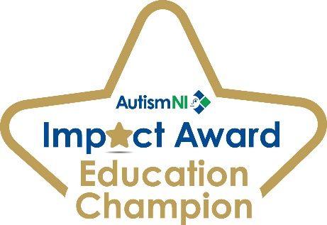
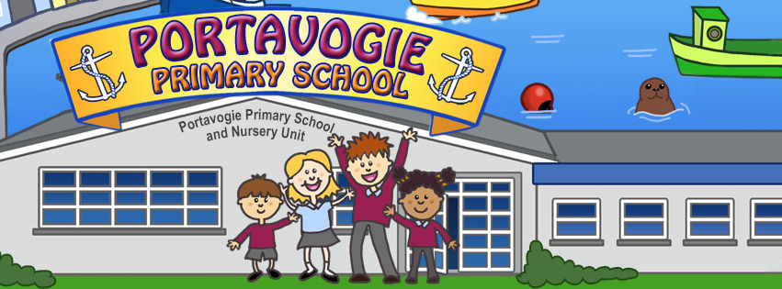
(Principal)

