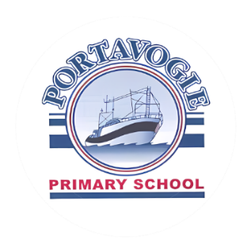
Thank you for your interest in enrolling your child at
Portavogie Primary School and Nursery Unit. We are always
happy to speak to prospective parents.
Admissions September 2026
Parents apply for Nursery via the Education Authority application system.
You should check the Education Authority website on how to apply for a place, key dates in the admissions procedure and preschool providers’ admissions criteria for September 2026 admissions https://www.eani.org.uk/parents/pupil-applications-and-grants/admissions

EA Admissions Helpdesk can be contacted by phoning,
028 95985595 Monday to Friday (9am – 5pm)
You can also contact the EA Admissions Helpdesk at the following email address below:
Pre-School preschooladmissions@eani.org.uk

Below are the important dates in the application process.
Wednesday 10th December 2025 | Admissions criteria for Pre-schools published on the EA website.
Wednesday 7th January 2026 at 12 noon | EA Connect opens for online applications for pre-school, submitting verification / supporting documents.
Wednesday 21st January 2026 at 12 noon | EA connect closes. Last date/time for punctual applications for Pre-School.
Monday 26th January 2026 by 4pm | Final date/time for late applications.  Final date/time for Change of Preference in Exceptional Circumstances.  Final date/time for documents in support of applications.
Monday 23rd March 2026 | Pre-School Stage 1 – Target Age Only – Parents will receive application outcome via email (where one is held) or by letter.
Tuesday 19th May 2026 | Pre-School Stage 2 – Parents will receive application outcome via email (where one is held) or by letter.
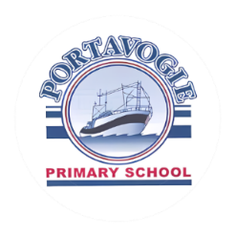
Why Choose Portavogie Primary School Nursery Unit for Your Child?
Choosing the right start for your child’s education is a big step, and we’re here to help make it an easy decision. Our Nursery Unit provides a caring and stimulating environment where children can thrive as they begin their educational journey.
This is what makes our Nursery special:
- Full-Day Nursery: Our Nursery runs from 9:00 am to 1:30 pm, offering a full day of engaging activities. This not only provides your child with a rich learning experience but also helps families save on childcare costs.
- Learning Through Play: We deliver all areas of the Nursery Curriculum through hands-on, practical learning. Your child will explore and develop key skills in:
o Personal, social, and emotional development
o Physical development and movement
o Language and communication skills
o Early mathematics
o The Arts
o Understanding the World Around Us
- Supportive Environment: Our experienced and caring staff are committed to nurturing your child’s confidence, curiosity, and love of learning.
At Portavogie Nursery, we aim to make every day exciting and enriching, laying a strong foundation for your child’s future education.

We would love to meet you and share more about what our Nursery Unit has to offer. Thank you for considering Portavogie Primary School for your child’s early years education.
Victoria Murray
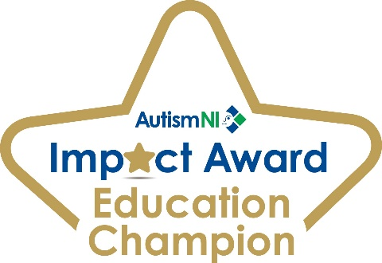
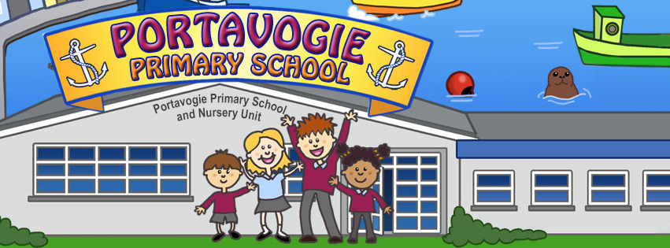
(Principal)

